**UNIVERSITY OF THE PUNJAB**

**GUJRANWALA CAMPUS**



**Department of Information Technology**

**Computer Vision**

**Assignment**

* **Submitted by:**

Hammad Bin Tariq

* **Session:**

BSIT 7th semester

* **Roll no:**

(BIT21203) Afternoon

* **Submitted to:**

Mam Fouqia Zafeer

**Topic:**

**Intensity Transformation (MATLAB Code)**

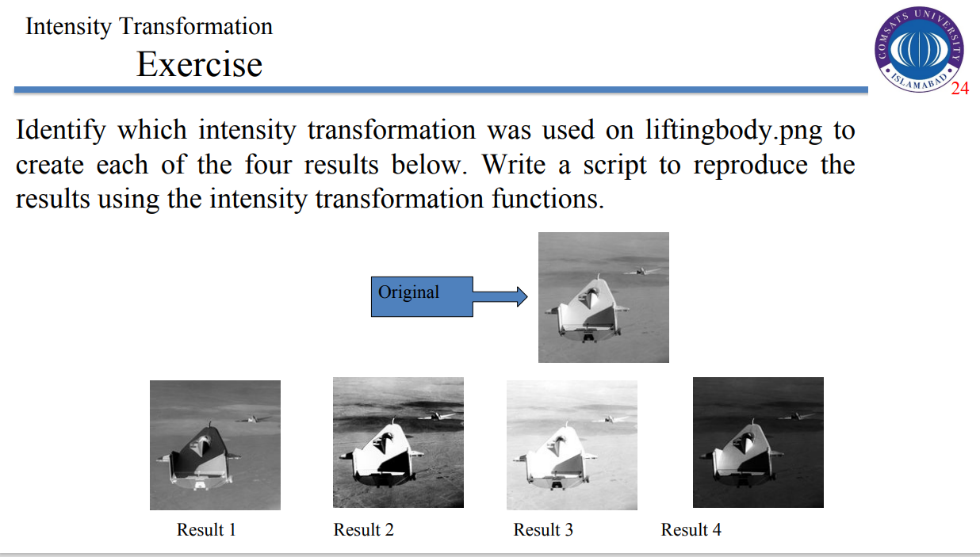

**MATLAB Code:**

% Read the original image

image = imread('liftingbody.png');

image = im2gray(image); % Convert to grayscale if needed

% 1. Image Negative

negative_image = 255 - image;

% 2. Contrast Stretching

min_intensity = double(min(image(:)));

max_intensity = double(max(image(:)));

contrast_stretched = uint8(255 * (double(image) - min_intensity) / (max_intensity - min_intensity));

% 3. Power Law (Gamma Correction)

gamma = 2.5; % Adjust gamma value as needed

power_law_image = uint8(255 * ((double(image) / 255) .^ gamma));

% 4. Logarithmic Transformation

c = 255 / log(1 + double(max(image(:))));

log_transformed = uint8(c * log(1 + double(image)));

% Display Results

figure;

subplot(2, 3, 1);

imshow(image);

title('Original Image');

subplot(2, 3, 2);

imshow(negative_image);

title('Image Negative');

subplot(2, 3, 3);

imshow(contrast_stretched);

title('Contrast Stretching');

subplot(2, 3, 4);

imshow(power_law_image);

title('Gamma Correction');

subplot(2, 3, 5);

imshow(log_transformed);

title('Log Transformation');

**Output:**

